Git Guide

By Karol Loughlin

1. Init = initialises a git repository inside of a folder.
2. 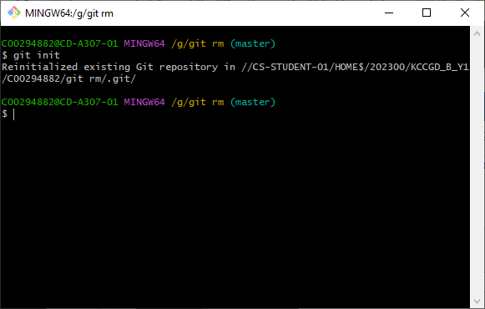
3. Add = adds a change in the working directory into the staging area. In the format ”git add .”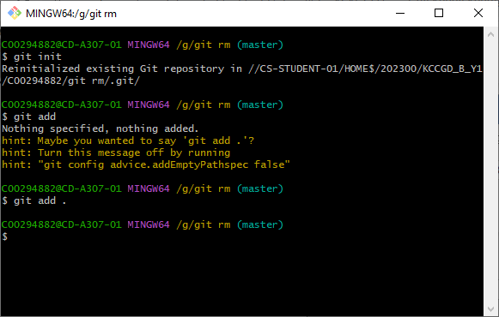
4. Status = Displays the state of the working directory and the staging area. FORMAT git status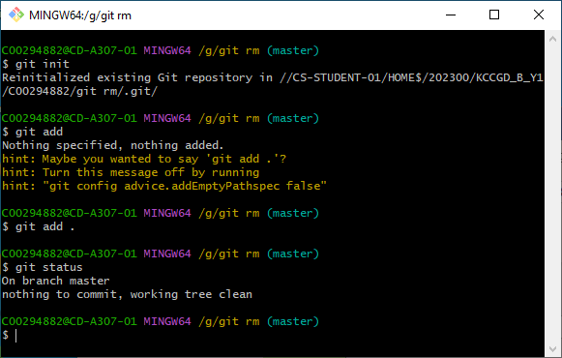
5. Commit = will enter editor mode for comments, and/or make a new revision point on repository. Git commit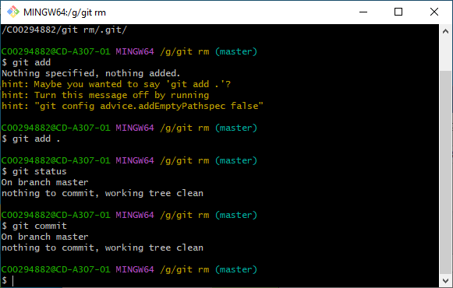
6. Remote = git remote -v : lists repositories on the remote server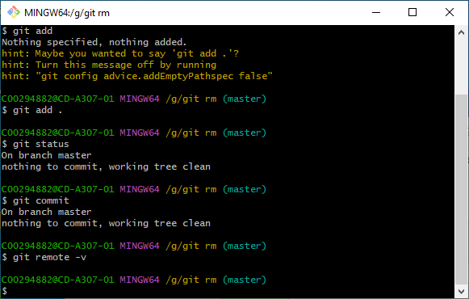
7. Push = this will update the remote node with the current node. User need to associate remote node. Git push <name>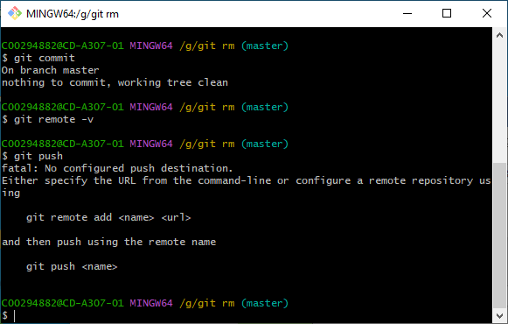
8. Branch = lists branches on a repository. Git branch -r to list branches on remote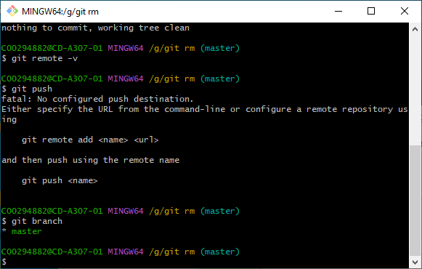
9. Checkout = git checkout branch_name : makes the node a current HEAD. This will not work if there is modified files. 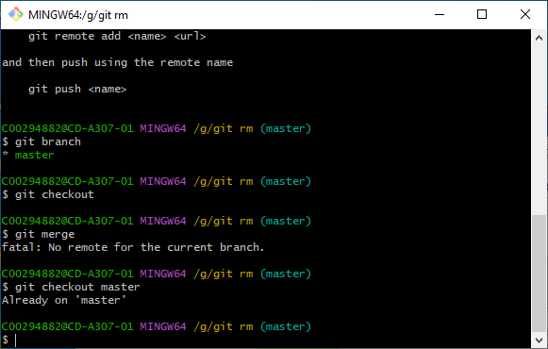
10. Merge, specifically git merge master : merges HEAD with master. Git automatically applies changes if separate. Edit files and then commit.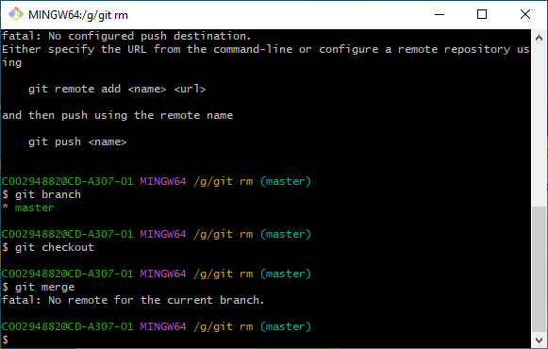
11. Log, specifically git log -n lists only the last n commits. 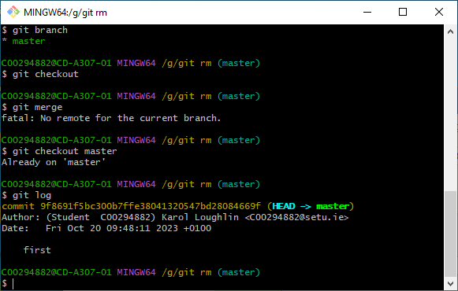
12. Clone = clones a repository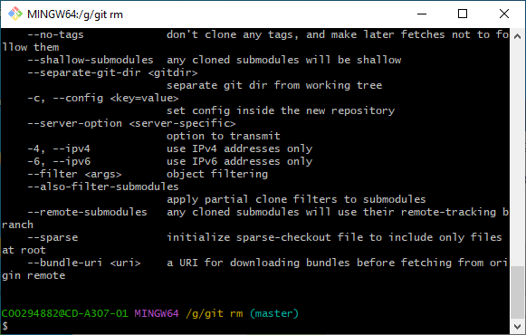
13. Pull = pulls a branch from a remote server.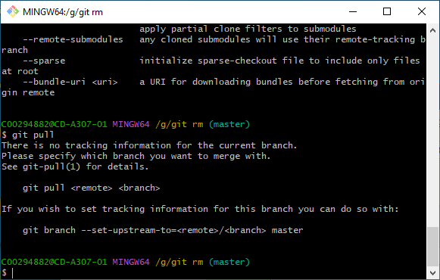
14. Stash = saves local repository’s changes. 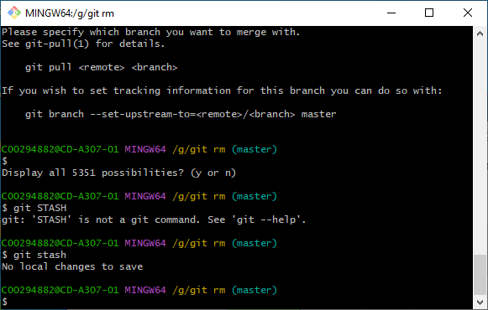
15. Remove = Git rm removes files from staging area in the format : git rm filename. Can use wildcards and -r for recursive. Use - - cached to remove from staging area Use -f to use on working directory.

